Plate Tectonics Note

*Fill out this sheet as we go through the powerpoint presentation to help create your note*
Natural Environment

What comes to mind when you think of the words: Natural Environment. Write down as many terms you can

Key Questions (What are they?)

- __________________________________________________________________

- __________________________________________________________________

- __________________________________________________________________

PANGAEA

What does the word Pangaea mean?
When did it exist?
What shape did it take?
What is one significant factor to this supercontinent?
Label:
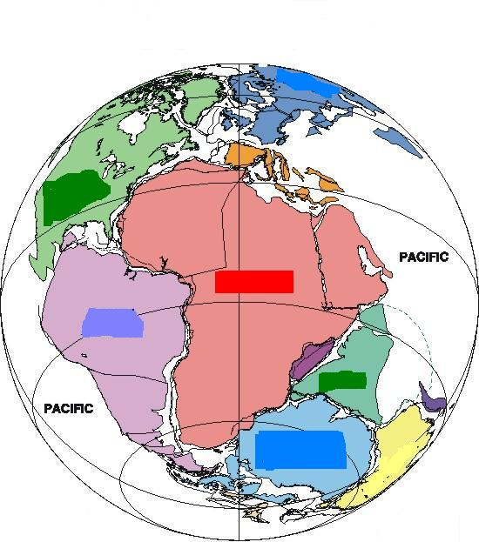
Who came up with the idea of Pangaea? And who was he?

What was the name given to the movement of continents?

List Wegener’s 4 proofs:

- __________________________________________________________________ ____________________________________________________________________________________________________________________________________

- __________________________________________________________________ ____________________________________________________________________________________________________________________________________

- __________________________________________________________________ ____________________________________________________________________________________________________________________________________

- __________________________________________________________________ ____________________________________________________________________________________________________________________________________

The problem Wegener faced was:

Who solved it?
Who was he?

The new, complete theory is called: ________________________________________

PLATE TECTONICS

Earth’s outer shell is made up of: __________

Which consist of: ______________________________

That are situated: _______________________________________
_______________________________________

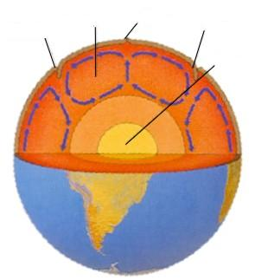

Label:

What is the process behind the movement of tectonic plates?

Definition:

Summarize the process of convection currents

The resulting motion is ____________________________

CONVECTION CURRENTS and EARTH (Copy the slide as is)

Where is our heat source?

Therefore,

The movement . . .

Watch the clips: Plate Tectonics: An Introduction, Plate Tectonics: The Scientist Behind the Theory and Plate Tectonics: Further Evidence and answer:

- Why was Wegener’s original idea about continental drift referred to as an institution and not science?

- Why didn’t others think that his findings constituted evidence?

- How did the rocks at Lake Mead support the theory of plate tectonics?

